**Lesson 07 Demo 02**

**Analyzing Requirements Using GenAI**

**Objective:** To analyze requirements and generate detailed acceptance criteria for the user stories using ChatGPT for enhancing the Software Testing Life Cycle

**Tools required:** ChatGPT 4

**Prerequisites:** None

Steps to be followed:

1. Clarify requirements using ChatGPT 4
2. Generate the focus areas using ChatGPT 4
3. Generate acceptance criteria using ChatGPT 4

**Note:** Please be advised that ChatGPT, as an artificial intelligence tool, can produce varied outputs even when presented with similar prompts.

**Step 1:** **Clarify requirements using ChatGPT 4**

* 1. Browse to the **https://chat.openai.com** website and log in to your account  
       
     A screenshot of a computer

     Description automatically generated

|  |
| --- |
| **Note**: Sign up if you do not have an account |

* 1. Use the following prompt to input broad requirements, as shown in the screenshot below:  
     **Improve product recommendations based on user activity.**  
       
     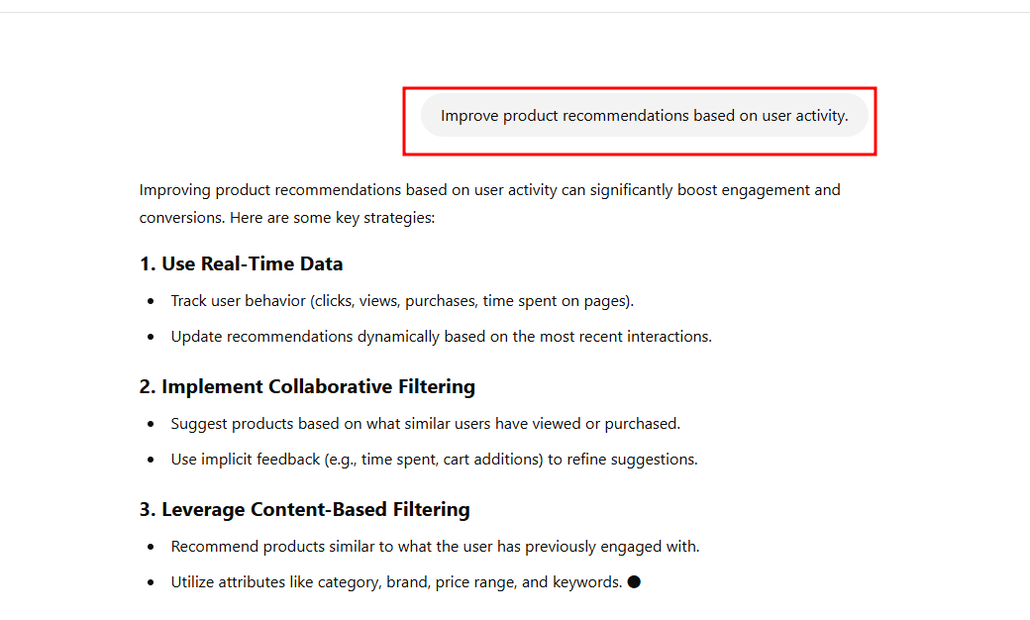 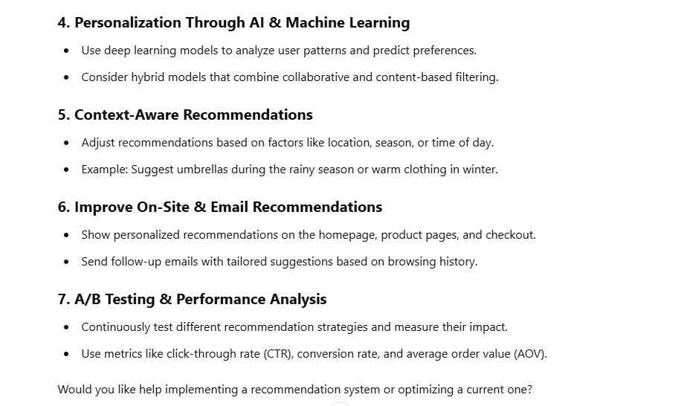
  2. Use the following prompt for clarification, as shown in the screenshot below:

**Given the requirement to improve product recommendations based on user activity, what specific questions should I ask the development team to clarify this requirement?**

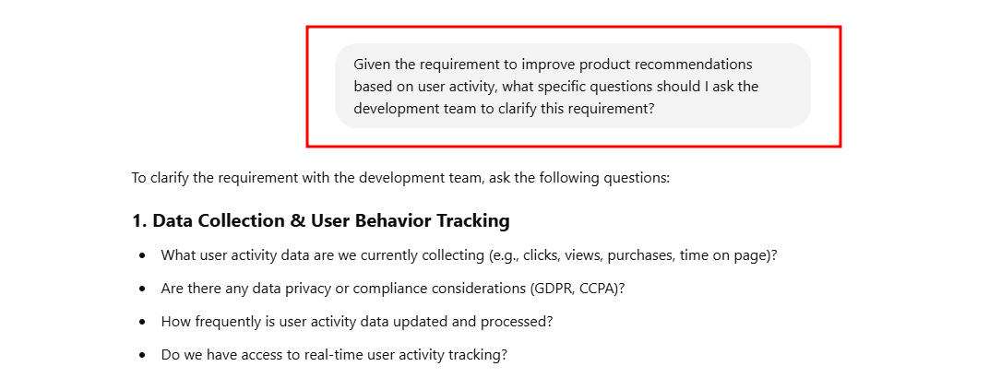

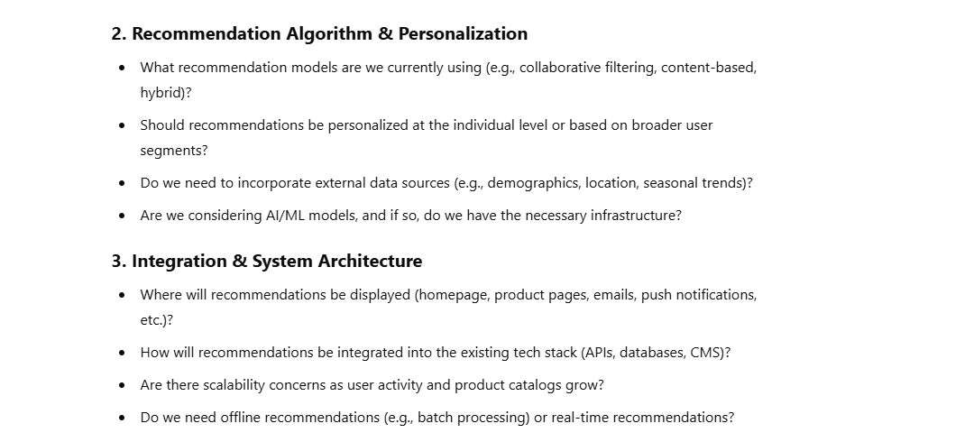

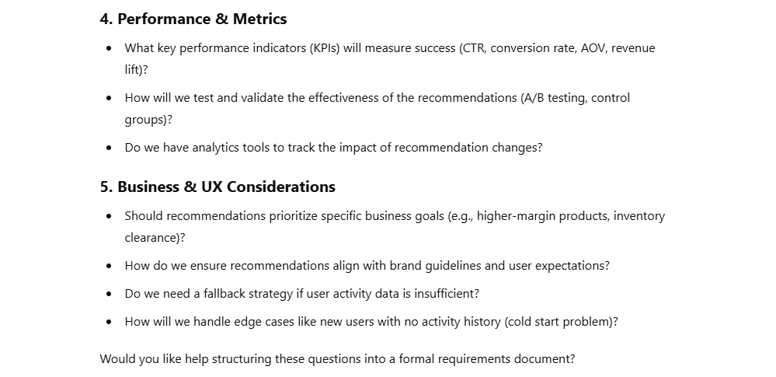

* 1. Use the following prompt to refine the requirements, as shown in the screenshot below:  
     **Based on the previous discussion where we identified the need to clarify the initial requirement of improving product recommendations based on user activity, here are two specific questions:**

**What specific user activities are currently tracked that could influence product recommendations?**

**What additional user activity data do we need to improve the recommendations?**

**Could you help draft a more detailed requirement that addresses these points? Please include any assumptions or conditions that might affect the implementation of these features.**

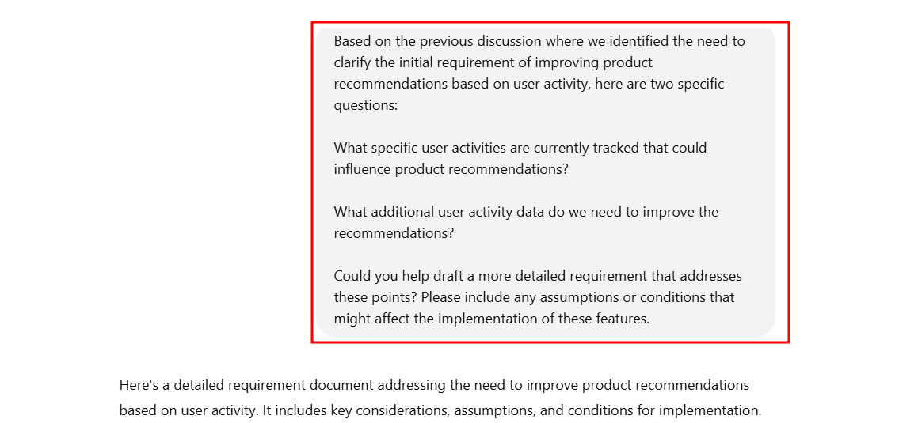

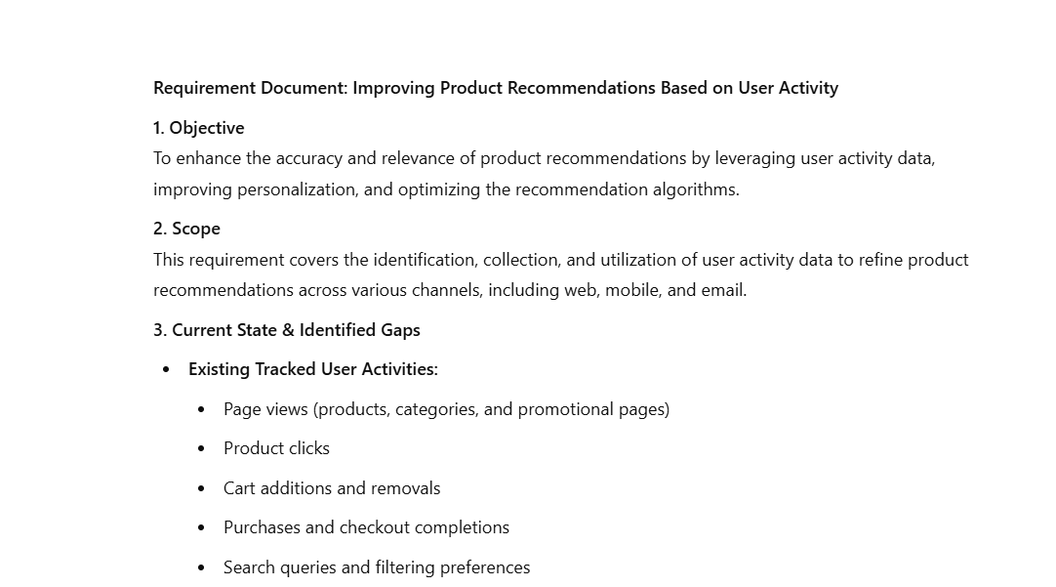

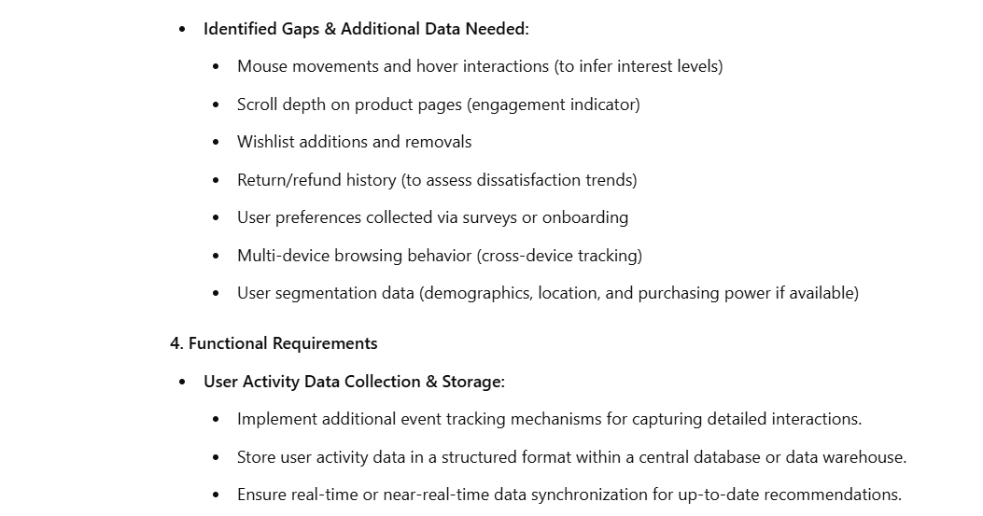

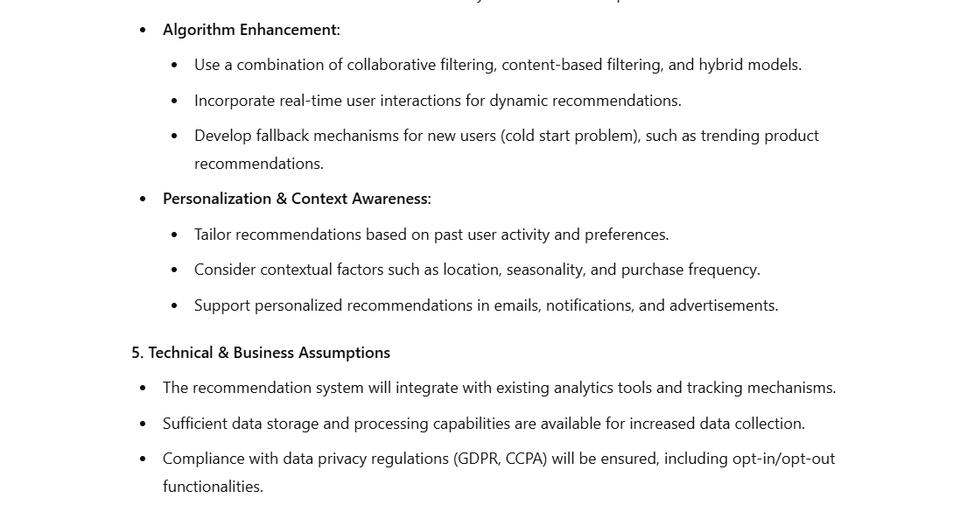

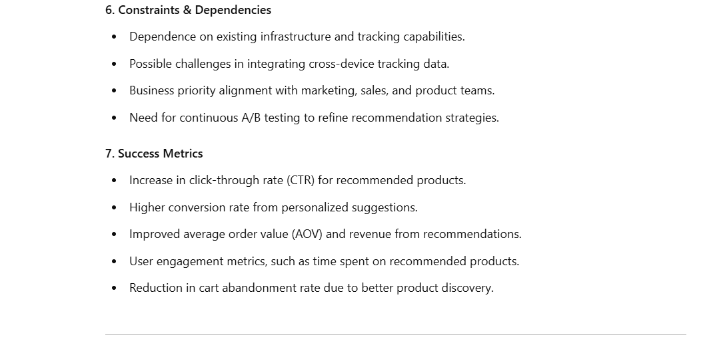

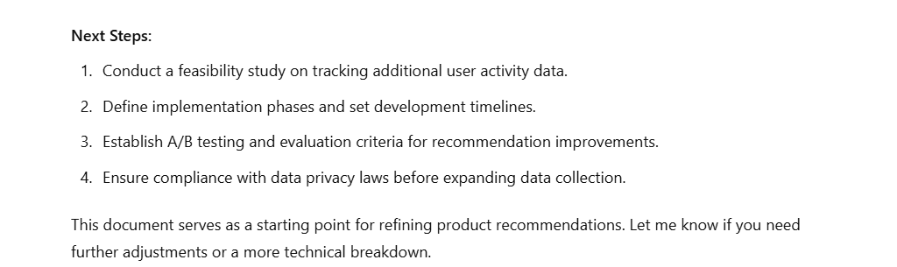

**Step 2:** **Generate the focus areas using ChatGPT 4**

* 1. Upload the market and user data and generate targeted suggestions using the prompt provided in the screenshot below:  
     **Based on the following user feedback and market analysis data, what areas should we focus on to improve our software application?**  
       
     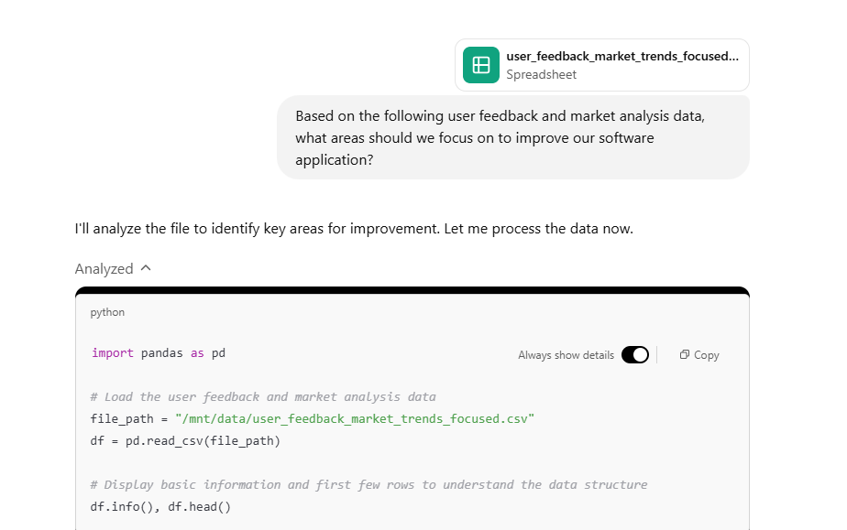

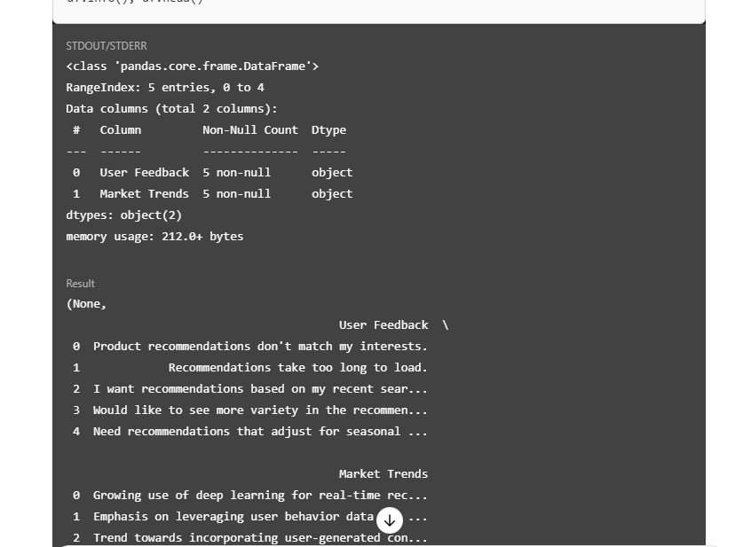

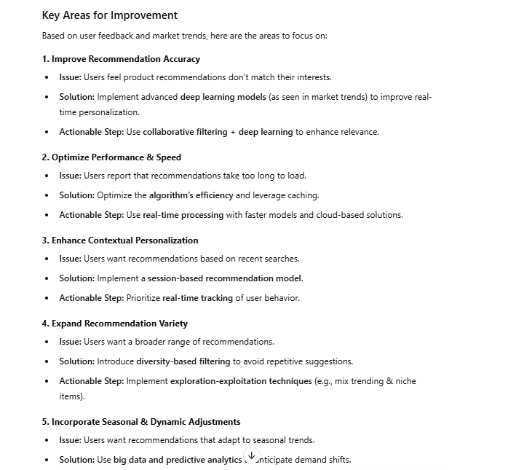

Once you get to the focus areas, you may discuss the feasibility and relevance of the focus areas with the project team.

* 1. Use the following prompt to adjust the priorities, as shown in the screenshot below:  
     **Given the recommended focus areas to enhance our recommendation engine with deep learning, expand data analytics, and improve personalization and variety, how should we adjust our software development and testing priorities to best implement these improvements efficiently and effectively?**  
       
     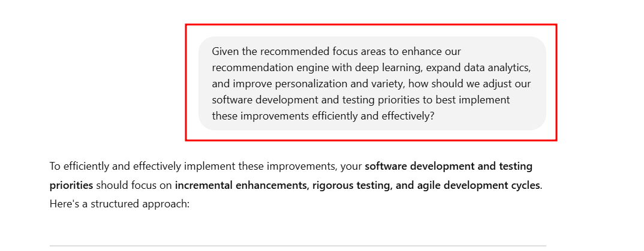

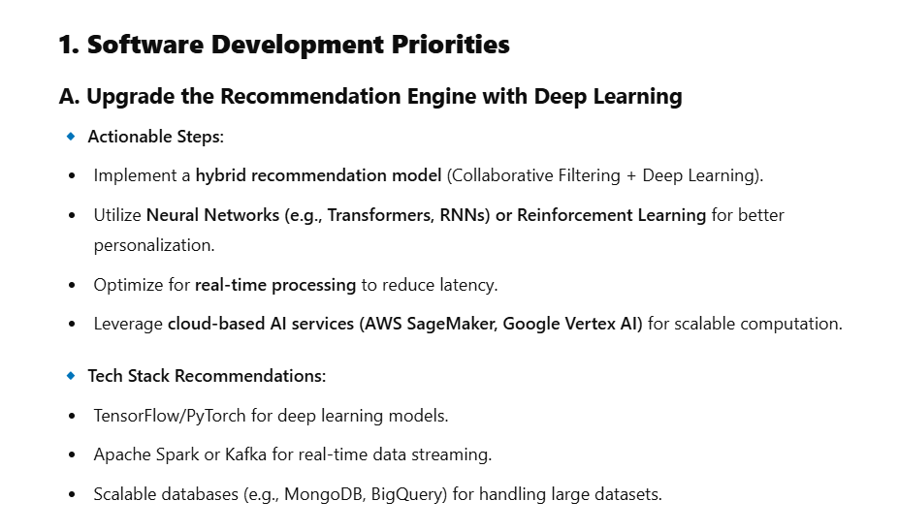

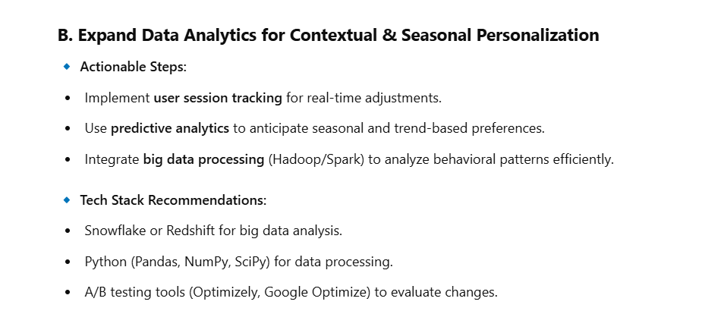

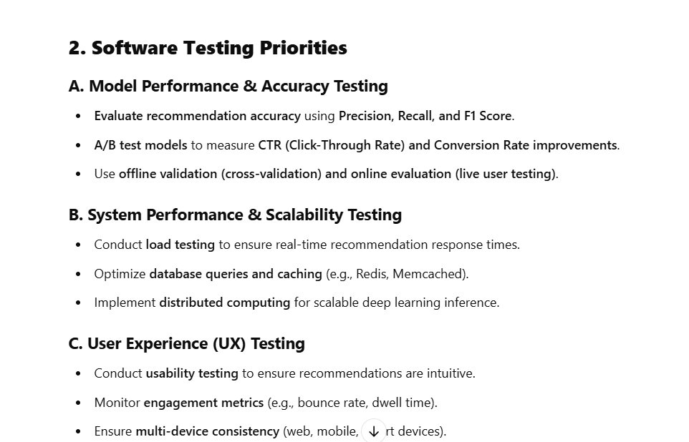

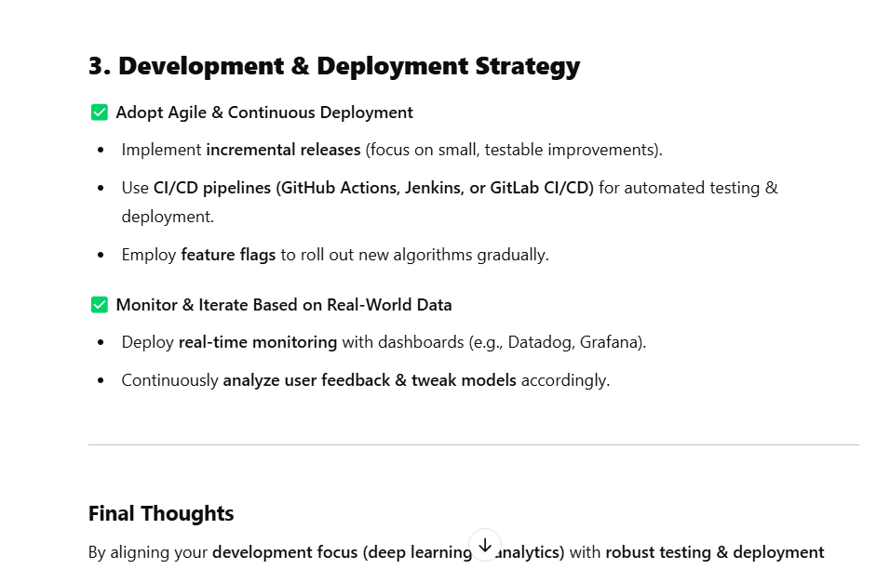

**Step 3:** **Generate acceptance criteria using ChatGPT 4**

* 1. Upload the user stories and use the following prompt to generate the acceptance criteria, as shown in the screenshot below:  
     **What should be the acceptance criteria for this user story to ensure it meets the user's needs?**  
       
     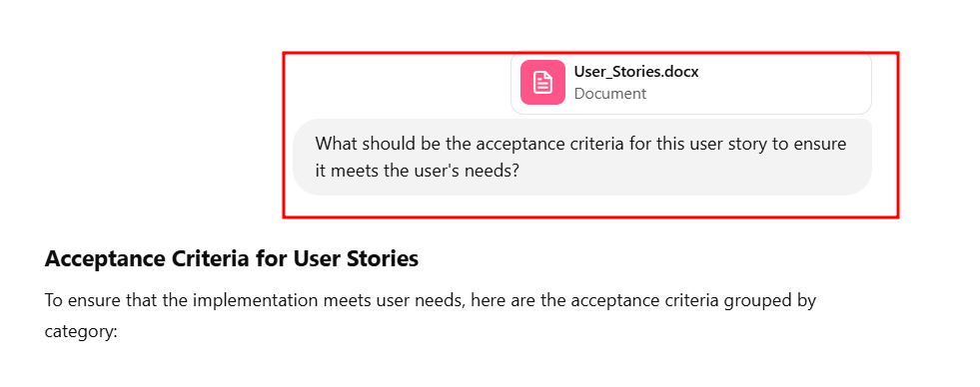

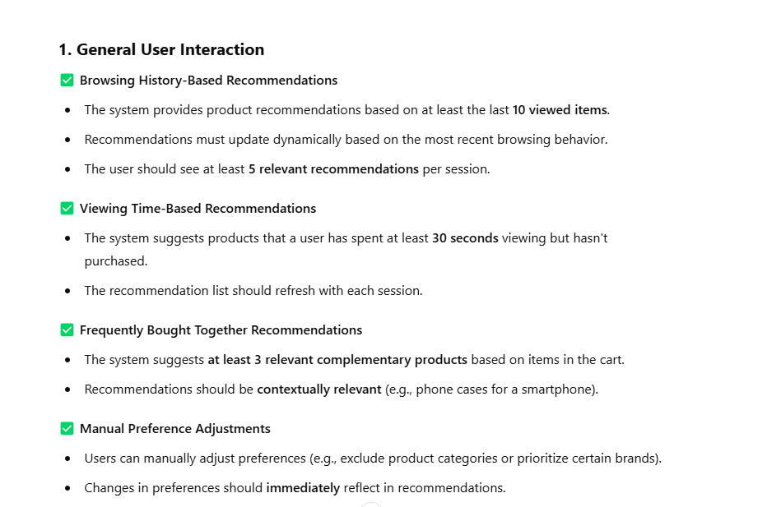

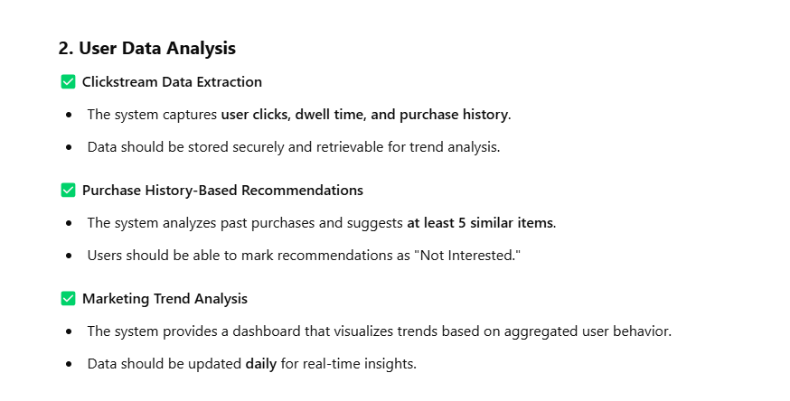

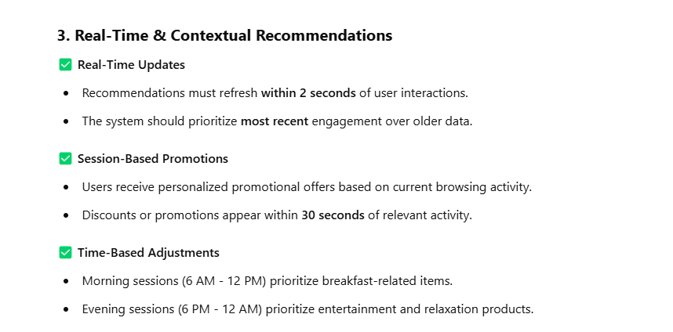

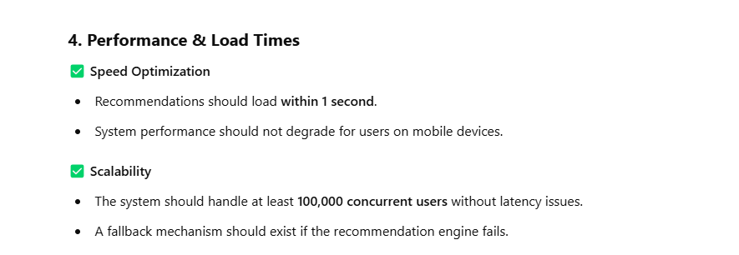

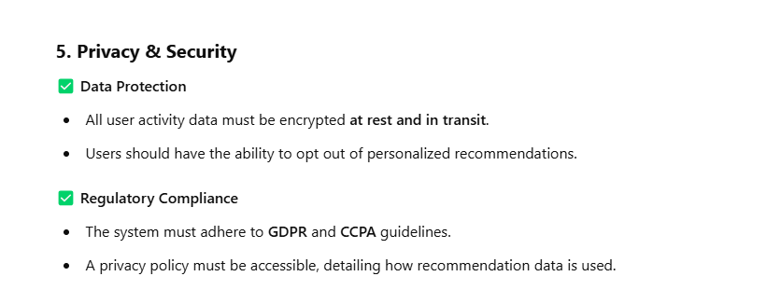

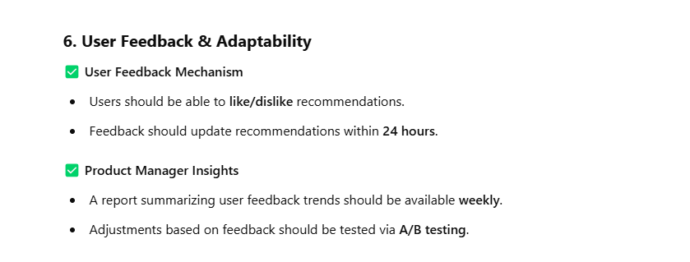

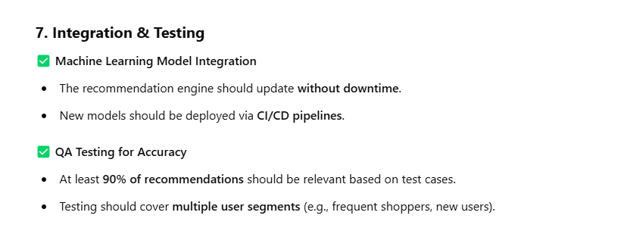

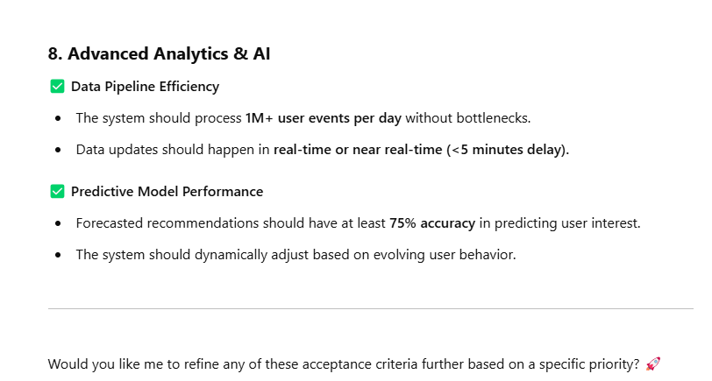

By following these steps, you have successfully analyzed requirements and generated detailed acceptance criteria using ChatGPT 4 to enhance the Software Testing Life Cycle.